One of the features added to Quattro to customize the Titan contract output is “Package” in the Segment.

Using the Package # and Package Description in the Segment will allow for grouping of “same” package information on a single line on the contract.

On the Segment Maintenance screen you have two fields

* Package #
* Package Description

These fields can be used in two ways

1. Group multiple segments together to display as a single line on the contract.

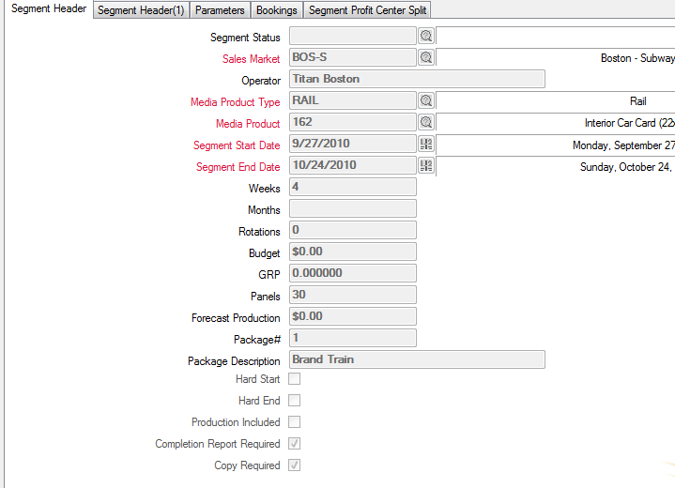

When entering Segments, insert the Package # and Package Description the “same” for each Segment that needs to be grouped together on this contract. For this example we have 2 segments, both with different Media Products, however, the Package # and Package description are the same. Following is how each segment is entered:



You can create 20 segments on a contract all with the same package # and description if they need to be pulled together as a single line item for output.

Output of the contract is as follows:

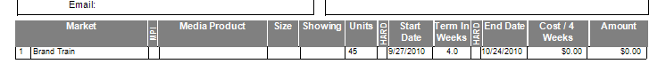

The Contract instructions will break out the line items for Invoicing.

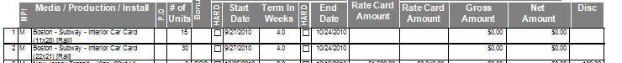

1. Another reason this is used is when a Sales person wants to see a custom description for lines on a contract. So, a package doesn’t need to be used for multiple lines, you can create individual custom lines for each Segment on your contract. This is done by using a different package number for each line item.

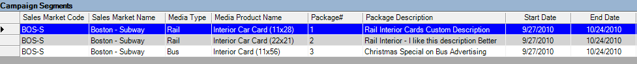

Note that each segment has it’s own package number and Package Description. Output on the contract would be:

